# ETHICAL AND BIAS AWARE FAKE NEWS DETECTION SYSTEM

1Dr. B. Suganya,

Department of Artificial Intelligence and Data Science,

Sri Ramakrishna Engineering College, Coimbatore, India

Email: [*suganya.b@srec.ac.in*](mailto:suganya.b@srec.ac.in)

2Aravind G, 3Lakshan V K, 4Sanjay R

Department of Artificial Intelligence and Data Science,

Sri Ramakrishna Engineering College, Coimbatore, India

Email: *aravind.2111006@srec.ac.in*

***Abstract -*** Fake news is a growing concern, influencing public opinion, elections, and social stability. Traditional fake news detection systems rely on black-box deep learning models, which often lack explainability and fairness.

Although machine learning models have demonstrated efficiency in fake news detection, many function as opaque systems, lacking transparency and ethical safeguards. This paper proposes a bias-aware fake news detection system that integrates deep learning models with explainable artificial intelligence (XAI) to address the dual challenges of opacity and algorithmic bias. Leveraging Local Interpretable Model-Agnostic Explanations (LIME) and SHapley Additive exPlanations (SHAP), the system elucidates model decision processes, fostering interpretability and user trust.

Furthermore, fairness-aware learning strategies are employed to mitigate systemic biases present in training data, thereby ensuring equitable treatment across different content sources and topics. Security risks related to adversarial attacks on explainability are also addressed. The proposed system ensures higher transparency, fairness, and robustness, significantly improving trustworthiness in automated misinformation detection.

***Keywords:*** Fake News Detection, Explainable AI (XAI), Bias Mitigation, Deep Learning, Fairness in AI, LIME, SHAP, Algorithmic Fairness, Natural Language Processing (NLP), Ethical AI, Misinformation, Neural Networks, Transparency, Data-Driven Decision Making, Adversarial Robustness, Real-Time Classification.

1. **Introduction**

In recent years, social media has emerged as a dominant conduit for news consumption, offering immediacy and broad accessibility. However, the same features that facilitate information dissemination also enable the rampant spread of fake news, fabricated content intentionally crafted to mislead readers for political, economic, or ideological purposes. The challenge of mitigating the impact of fake news is not merely technical but also ethical, as models must be transparent, fair, and trustworthy to serve their intended purpose effectively.

Studies indicate a sharp increase in public reliance on social media for news, with over 60% of U.S. adults consuming news via these platforms by 2016. While this shift democratizes access, it also reduces gatekeeping by traditional journalistic entities, thereby increasing susceptibility to misinformation. As highlighted, fake news can distort public perception, manipulate electoral outcomes, and degrade the integrity of societal institutions. Consequently, the development of robust fake news detection systems has become an urgent research imperative.

Existing machine learning approaches to fake news detection often prioritize classification accuracy but fall short in two critical dimensions: interpretability and fairness. As noted by Ribeiro et al, users are unlikely to adopt or trust a model if its predictions cannot be understood. The so-called "black-box" nature of many deep learning models impedes transparency, making it difficult for stakeholders to comprehend, evaluate, or contest decisions. Moreover, these models often inherit biases from their training datasets, leading to disproportionate misclassification of content from certain sources or topics, thereby raising concerns of algorithmic fairness.

To address these shortcomings, we propose a comprehensive fake news detection framework that integrates deep learning with explainable AI (XAI) and fairness-aware strategies. Deep learning models, such as Convolutional Neural Networks (CNNs) and Recurrent Neural Networks (RNNs), are adept at capturing intricate language patterns and semantic nuances that characterize fake news. However, to render these models interpretable, we employ Local Interpretable Model-Agnostic Explanations (LIME), SHapley Additive exPlanations (SHAP), XAI techniques that approximates the complex model locally and globally with a simpler surrogate model. This enables end-users to understand which features (e.g., specific words or phrases) contributed most significantly to a prediction, thereby enhancing trust and user engagement.

In parallel, the system incorporates mechanisms to detect and mitigate algorithmic biases. As outlined, social media data is inherently noisy, unstructured, and often reflects societal biases. Our framework addresses this by employing balanced datasets, bias detection metrics, and fairness optimization techniques during model training. This ensures that predictions are not only accurate but also equitable across various content types and demographics.

Furthermore, this research builds on key insights from both data mining and social theory. Shu et al. emphasize the importance of auxiliary information, such as user engagements and content propagation patterns, in understanding and identifying fake news. While our current system focuses on content-based detection, future work will incorporate these social signals to enhance contextual accuracy.

In summary, this paper contributes a novel, ethically grounded approach to fake news detection, prioritizing both predictive performance and responsible AI principles. By synergizing deep learning with LIME, SHAP and fairness-aware learning, the system addresses the core challenges of transparency and bias in fake news detection, thus providing a scalable and trustworthy solution for real-world deployment.

1. **Literature Review**

## **Fake News Detection on Social Media: A Data Mining Perspective**

Social media's role in news consumption is a double-edged sword. While it offers rapid, cost-effective access to information, it also facilitates the spread of fake news—deliberately false content designed to mislead. Detecting such misinformation is challenging due to its deceptive nature and the vast, unstructured, and noisy data generated by user interactions. Traditional content-based detection methods fall short, necessitating the incorporation of auxiliary information like user engagement patterns. Advanced approaches now combine content analysis with social context, employing machine learning and deep learning techniques. However, issues like data quality, evolving misinformation tactics, and the need for real-time detection persist. Future research must focus on enhancing detection models, improving data quality, and fostering media literacy to effectively combat fake news on social platforms.

## **“Why Should I Trust You?” Explaining the Predictions of Any Classifier**

This seminal work introduces LIME (Local Interpretable Model-Agnostic Explanations), a technique designed to elucidate the predictions of any classifier in an interpretable and faithful manner. By approximating the model locally with an interpretable model, LIME provides insights into individual predictions, fostering trust and understanding. The authors also propose SP-LIME, a method that selects representative individual predictions and their explanations in a non-redundant way, addressing the broader challenge of model interpretability. Building upon their previous work, the authors argue for the necessity of model-agnostic approaches to interpretability in machine learning. They emphasize that understanding model behavior is crucial for debugging, comparison, and user trust.

1. **Methodology**

To develop an ethical and bias-aware fake news detection system, the proposed methodology encompasses several critical stages. These include data acquisition through web scraping, benchmark datasets and reputable news sources, preprocessing and annotation of the collected data, training a RoBERTa-base model for fake news classification, and integrating explainable AI techniques such as LIME and SHAP to ensure transparency and fairness in predictions. The system aims to identify and mitigate biases, providing interpretable insights into the model's decision-making process, thereby fostering trust and accountability in automated fake news detection.

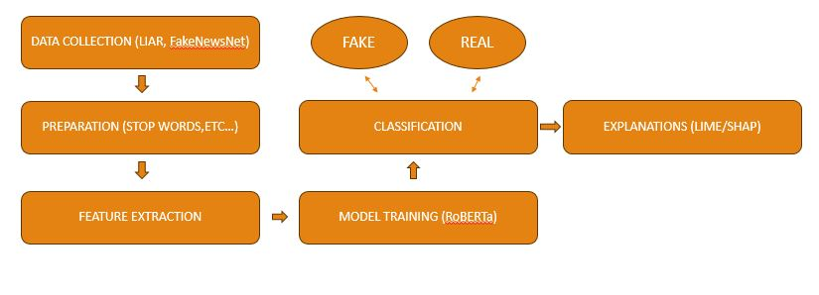

**Fig. 1. Block Diagram**

### **3.1. Data Collection and Preprocessing**

The system initiates by gathering news articles from diverse sources, including reputable news, known misinformation websites and combining multiple benchmark datasets. Web scraping techniques are employed to collect textual data, ensuring a balanced representation of various news categories. The collected data undergoes preprocessing steps such as tokenization, stop-word removal, and normalization to prepare it for model training. ​

### **3.2. Model Training with RoBERTa**

The pre-processed dataset is utilized to fine-tune the RoBERTa (Robustly Optimized BERT Pre training Approach) model for binary classification tasks, distinguishing between fake and real news. RoBERTa's deep contextual understanding enables it to capture nuanced linguistic patterns indicative of misinformation. ​

### **3.3. Explainability Integration using LIME and SHAP**

To enhance transparency and trust in the model's predictions, explainable AI techniques are integrated: ​

* **LIME (Local Interpretable Model-agnostic Explanations):** Provides local explanations by approximating the model locally with an interpretable model, highlighting which parts of the input contributed most to a specific prediction. ​
* **SHAP (SHapley Additive exPlanations):** Offers global interpretability by assigning each feature an importance value for a particular prediction, based on cooperative game theory. ​

These methods allow stakeholders to understand the rationale behind each classification, fostering trust and facilitating model debugging. ​

### **4. Bias Detection and Mitigation**

The system incorporates mechanisms to detect and mitigate biases that may arise from imbalanced training data or model architecture: ​

* **Bias Detection:** Analyzing model predictions across different demographic groups to identify disparities. ​
* **Mitigation Strategies:** Implementing techniques such as re-sampling, balancing, adversarial de-biasing to address identified biases, ensuring fair and equitable model performance.

### **5. Evaluation and Validation**

The model's performance is evaluated using standard metrics: ​

* **Accuracy:** Overall correctness of the model's predictions. ​
* **Precision and Recall:** Measures of the model's ability to correctly identify fake news.
* **F1-Score:** Harmonic mean of precision and recall, providing a balance between the two. ​

Additionally, the effectiveness of the explainability and bias mitigation components is assessed through qualitative analyses and stakeholder feedback. ​

### **6. Deployment and Monitoring**

Upon satisfactory evaluation, the model is deployed within a user-friendly and good-looking web application that uses HTML, CSS, JavaScript and flask. Continuous monitoring is established to: ​

* Track model performance over time. ​
* Detect and address potential model drift. ​
* Incorporate user feedback for ongoing improvements.

1. **Results**

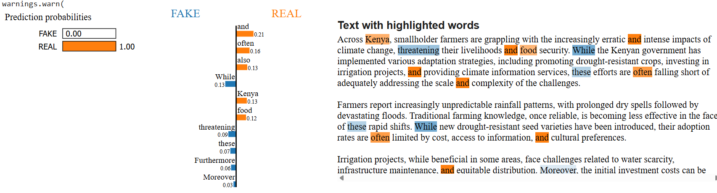

**Fig. 1. LIME (evaluation-1)**

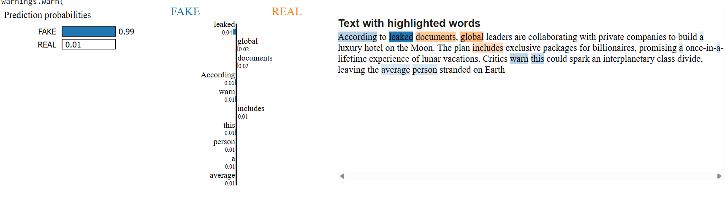

**Fig. 2. LIME (evaluation-2)**

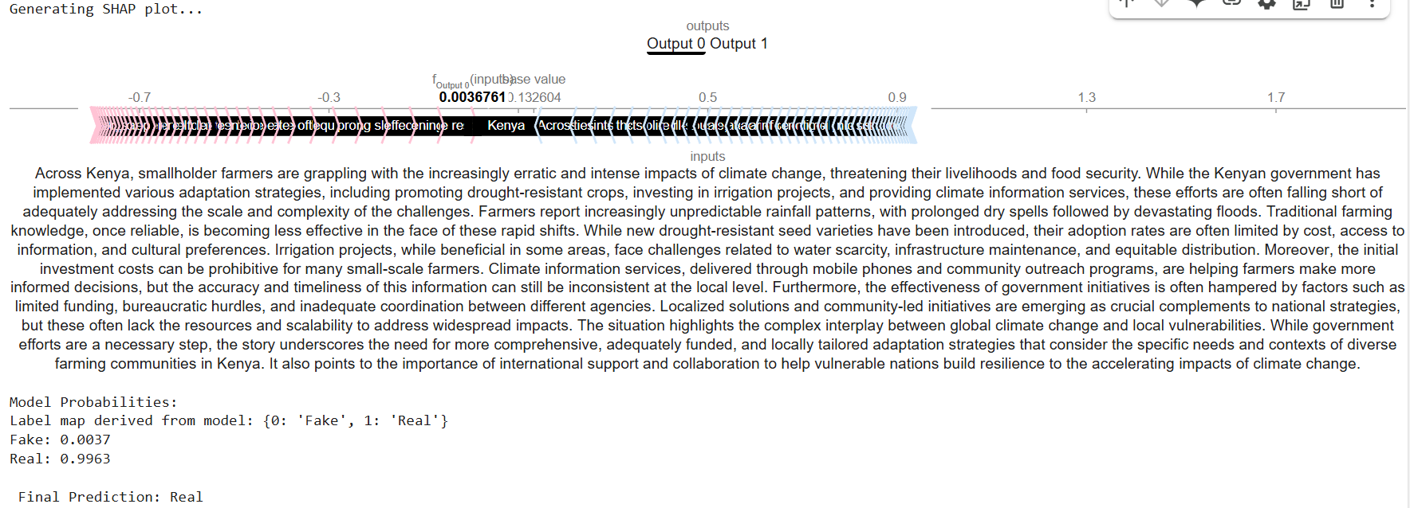

**Fig. 3. SHAP (evaluation-1)**

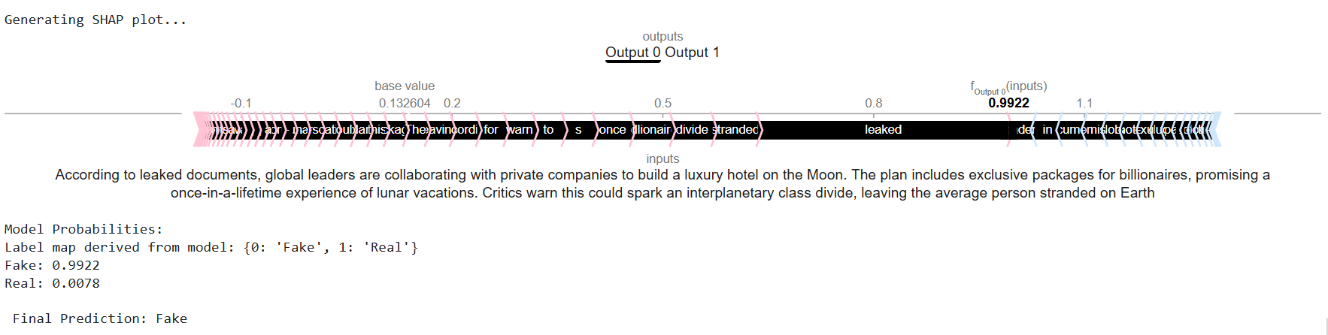

**Fig. 4. SHAP (evaluation-2)**

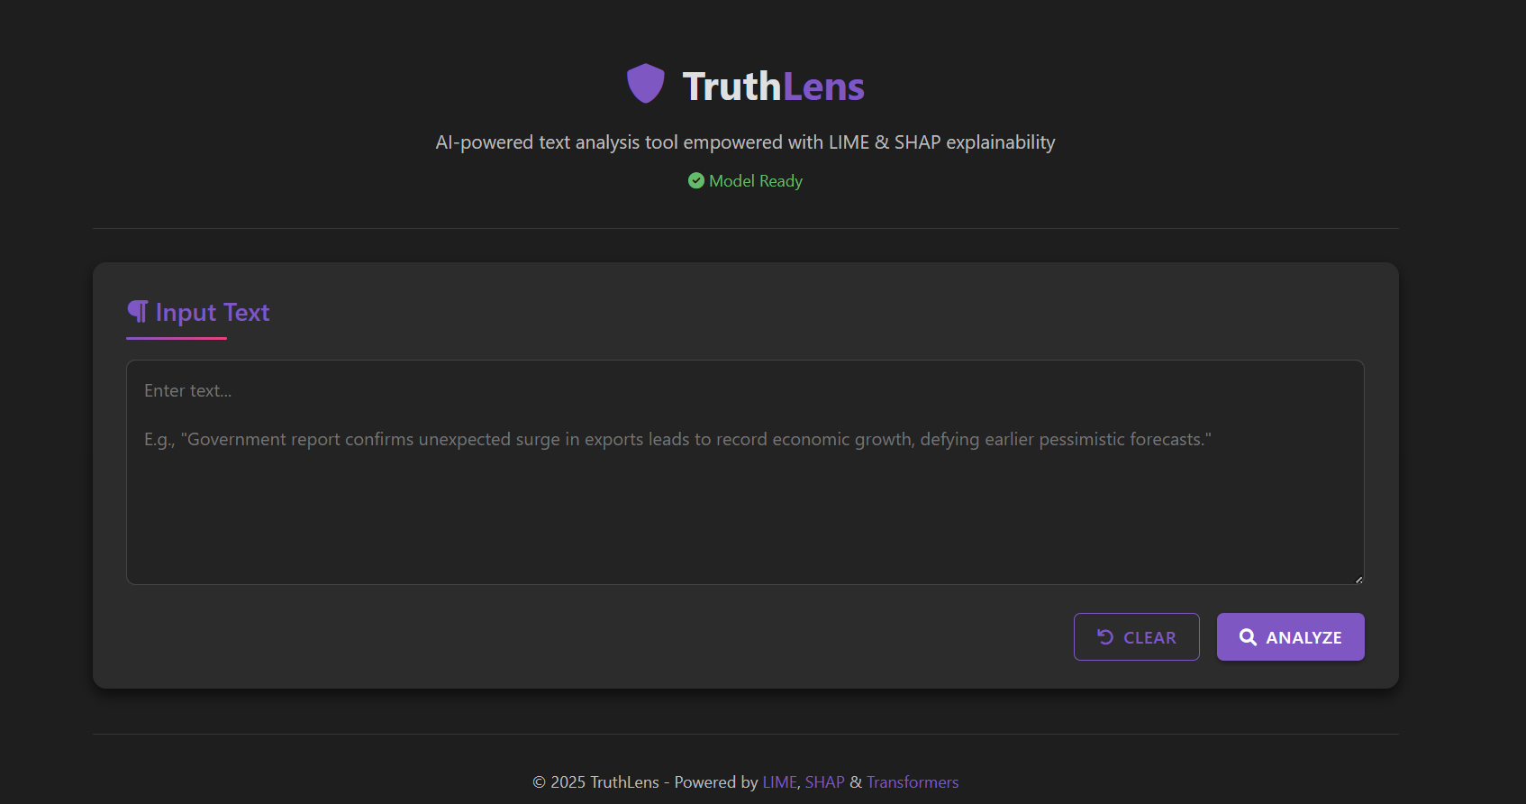

**Fig. 5. User Interface Homepage**

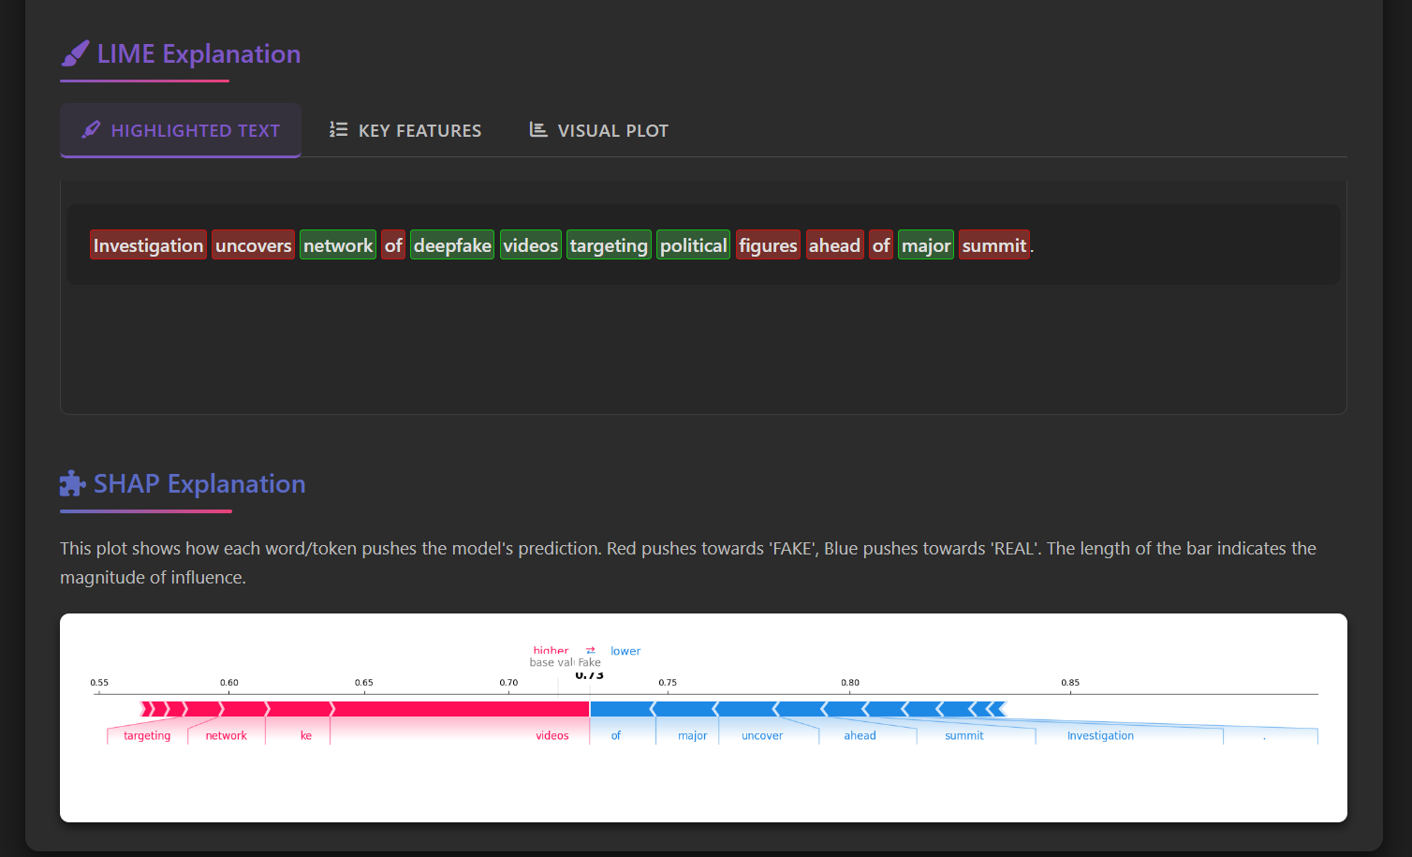

**Fig. 6. User Interface – LIME and SHAP explanations**

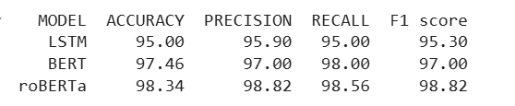

**Fig. 7. Metrics across Models**

**V. CONCLUSION AND FUTURE ENHANCEMENTS**

​ In conclusion, the proliferation of misinformation in digital media necessitates advanced solutions for fake news detection. This project presents an ethical and bias-aware detection system leveraging RoBERTa for robust text classification, complemented by LIME and SHAP for explainable AI (XAI) to enhance transparency and trustworthiness. By integrating these technologies, the system not only identifies deceptive content but also provides interpretable insights into its decision-making process, addressing the critical need for accountability in AI applications. ​

The use of a custom dataset, compiled through comprehensive web scraping and diverse news sources, ensures the model is trained on a wide array of information, promoting generalizability and reducing potential biases. This approach aligns with ethical AI practices, emphasizing fairness and inclusivity in model training and deployment. ​

Future enhancements to this system could involve incorporating multilingual capabilities to detect fake news across different languages, reflecting the global nature of misinformation. Additionally, integrating real-time data processing would allow for prompt identification and mitigation of emerging fake news stories. Exploring the use of transformer-based models with attention mechanisms may further improve the system's ability to discern nuanced patterns in text, enhancing detection accuracy. ​

Moreover, expanding the system's scope to include multimedia content analysis, such as images and videos, could provide a more comprehensive tool against misinformation. Implementing user feedback mechanisms would also enable continuous learning and adaptation, ensuring the system remains effective against evolving fake news tactics.

**References:**

1. C.-H. Chuan et al., “Explainable Artificial Intelligence (XAI) for Facilitating Recognition of Algorithmic Bias,” *Telematics and Informatics*, vol. 91, 2024.
2. R. Kozik et al., “When Explainability Turns Into a Threat – Using xAI to Fool a Fake News Detection Method,” *Computers & Security*, vol. 137, 2024.
3. H. Liu et al., “TELLER: A Trustworthy Framework for Explainable, Generalizable and Controllable Fake News Detection,” *arXiv preprint*, arXiv:2402.07776v2, 2024.
4. [B. Wang et al., “Explainable Fake News Detection With Large Language Model via Defense Among Competing Wisdom,” in *Proc. ACM Web Conf. (WWW)*, 2024.
5. Q. Dong et al., “EMIF: Evidence-aware Multi-source Information Fusion Network for Explainable Fake News Detection,” *arXiv preprint*, arXiv:2407.01213v1, 2024.
6. E. Hashmi et al., “Advancing Fake News Detection: Hybrid Deep Learning with FastText and Explainable AI,” *IEEE Access*, vol. 12, Mar. 2024.
7. J. Kathiriya and S. Degadwala, “A Review on Fake News Detection using Deep Learning Methods,” *Int. J. Sci. Res. Comput. Sci. Eng. Inf. Technol.*, vol. 10, no. 3, 2024.
8. Z. Zhang et al., “Explainable Artificial Intelligence Applications in Cyber Security: State-of-the-Art in Research,” *IEEE Access*, vol. 10, 2022.